From: <https://cynthiachung.substack.com/p/the-special-relationship-how-the>

Date: Jul 27, 2022

Through a Glass Darkly

‘The Special Relationship’, How the British Reconquered the United States and Established an Anglo-American Empire

“*Neither the sure prevention of war, nor the continuous rise of world organisation will be gained without … a****special relationship between the British Commonwealth and Empire and the United States****…not only the growing friendship and mutual understanding between our two vast but kindred systems of society, but the continuance of the intimate relationship between our military advisers*”.

– Winston Churchill, ‘Iron Curtain Speech’, 1946

This will sound like an outrageous statement to many. How could the British have reconquered the United States?! They never won any war against her and by the 20th century had always fought alongside the United States as a trusted ally. And isn’t it rather the opposite, doesn’t the United States dictate British foreign policy at this point?

It is true, Britain never won a war against the United States, and it was understood by the mid-19th century that the British would never succeed in conquering the United States externally. Rather, if they were to be successful, she would need to be conquered *from within*, to which this paper is dedicated to telling the story of.

## Two Opposing Systems

During the American Civil War, British support for the Confederate army had reached a point where Britain would have certainly militarily intervened on their behalf if it had not been for Tsar Alexander II [deploying the Russian navy](https://cynthiachung.substack.com/p/why-russia-saved-the-united-states-60f) on both eastern and western coasts of America for seven months in support of Lincoln’s Union. Russia was prepared to go to war with Britain in order to keep the United States whole.

Tsar Alexander II explained [in an interview](https://cynthiachung.substack.com/p/why-russia-saved-the-united-states-60f) with pro-industry American banker Wharton Barker on Aug. 17, 1879 why he thought it important that Russia should take such a strong stance in America’s Civil War (published in *The Independent* March 24, 1904):

*“…All this I did because of love for my own dear Russia, rather than for love of the American Republic. I acted thus****because I understood that Russia would have a more serious task to perform if the American Republic, with advanced industrial development were broken up and Great Britain should be left in control of most branches of modern industrial development***.”

In other words, Tsar Alexander II understood that the United States had created the only economic system (known as “The American System”) that was capable of competing and defeating Britain’s slave-based economic policy of free trade. (For an overview of what is The American System refer [here](https://cynthiachung.substack.com/p/why-russia-saved-the-united-states-60f) and [here](https://cynthiachung.substack.com/p/what-it-means-to-be-an-american-citizen).)

In stark contrast to this sentiment, Lord Robert Cecil, who later became Marquess of Salisbury, a very prominent position in British peerage and who served three times as Prime Minister of Britain, had this to say in Parliament during the American Civil War:

“***The Northern States of America never can be sure friends because we are rivals, rivals politically, rivals commercially…With the Southern States, the case is entirely reversed****. The population are an agricultural people. They furnish the raw material of our industry, and they consume the products which we manufacture from it. With them, every interest must lead us to cultivate friendly relations, and****when the war began they at once recurred to England as their natural ally*.**”

In other words, the cotton plantations that ran on slave labour in the American South, were in service of the British Empire’s global cotton trade which also ran on slave labour from India and conducted terrible exploitation of its British cotton workers.

[[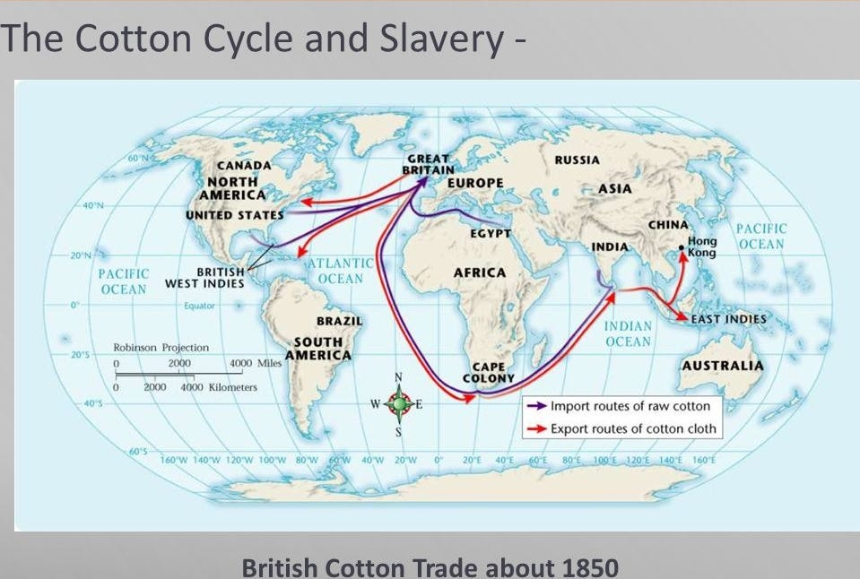](https://substackcdn.com/image/fetch/f_auto,q_auto:good,fl_progressive:steep/https:/bucketeer-e05bbc84-baa3-437e-9518-adb32be77984.s3.amazonaws.com/public/images/fd6d183a-8b46-47fc-a046-438689d4c9f0_959x646.jpeg)](https://substackcdn.com/image/fetch/f_auto,q_auto:good,fl_progressive:steep/https%3A%2F%2Fbucketeer-e05bbc84-baa3-437e-9518-adb32be77984.s3.amazonaws.com%2Fpublic%2Fimages%2Ffd6d183a-8b46-47fc-a046-438689d4c9f0_959x646.jpeg" \t "_blank)

The American Civil War was about two different economic systems in opposition to each other, and it was the South that was the “natural ally” to the British Empire.

However, the Union won the Civil War and the United States managed to keep itself whole. The South had to end its slave labour and the United States managed to push back on Britain’s slave-based economic policy (for more on this story [refer here](https://cynthiachung.substack.com/p/what-it-means-to-be-an-american-citizen)).

In fact, many leaders throughout the world, during this period were pushing back on Britain’s slave-based economic policy of free trade enforced by the British East-India Company. With leading opposition coming out of [Germany, Russia, Japan and China](https://cynthiachung.substack.com/p/why-russia-saved-the-united-states-60f), in addition to the United States.

In 1879, Otto von Bismarck broke Germany’s free trade system implementing an American style tariff policy for his nation. The kinship between Germany and the United States became so strong at this time that Otto von Bismarck’s speech in the parliament (1879) was quoted by McKinley on the floor in US Congress:

“*A success of the United States in material development is the most illustrious of modern time. The American nation has not only successfully born and suppressed the most gigantic and expensive war of all history, but immediately afterward disbanded its army, found employment for all its soldiers and marines, paid off most of its debt, given labour and homes to all the unemployed in Europe as fast as they could arrive within its territory and still by a system of taxation so indirect as not to be perceived, much less felt… Because it is my deliberate judgement that the prosperity of America is mainly due to its protective laws, I urge that Germany has now reached that point, where it is necessary to imitate the tariff system of the United States*.”

Otto von Bismarck was heavily organising for the building of **the Berlin to Baghdad railway**, which after much resistance and delay would only be completed in 1940. If this has been accomplished during Otto von Bismarck’s life, the Middle East could have avoided the [Sykes Picot carving up](https://cynthiachung.substack.com/p/the-clean-break-doctrine-a-modern-b76).

[[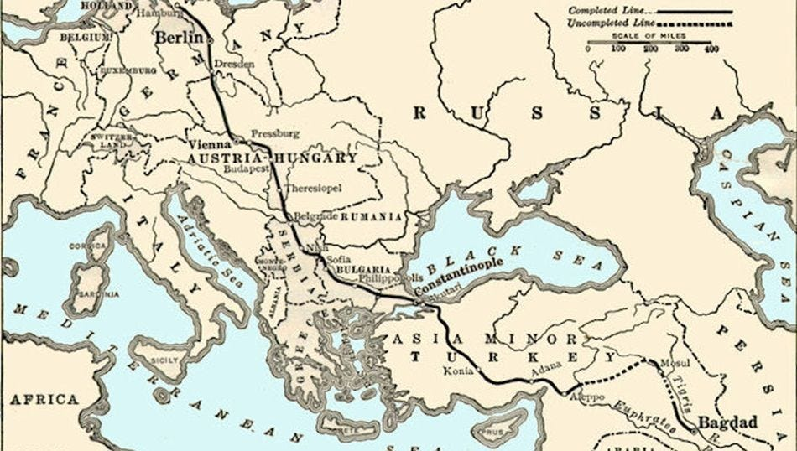](https://substackcdn.com/image/fetch/f_auto,q_auto:good,fl_progressive:steep/https:/bucketeer-e05bbc84-baa3-437e-9518-adb32be77984.s3.amazonaws.com/public/images/8c4428b6-32f9-4ac3-91e0-4ee48660370d_950x538.jpeg)](https://substackcdn.com/image/fetch/f_auto,q_auto:good,fl_progressive:steep/https%3A%2F%2Fbucketeer-e05bbc84-baa3-437e-9518-adb32be77984.s3.amazonaws.com%2Fpublic%2Fimages%2F8c4428b6-32f9-4ac3-91e0-4ee48660370d_950x538.jpeg" \t "_blank)

In 1869, Japanese modernizers working directly with the Lincoln-Carey strategists ran the Meiji Restoration which industrialized Japan.

In the 1880s and 90s, Lincoln-Carey Philadelphia industrialists were contracted for huge infrastructure and nation-building projects in China. Hawaiian Christian missionary Frank Damon, having participated in the Carey group’s strategies at a very high level, helped instigate, shape, and build the Sun Yat-sen organization that gave birth to modern China.

Sun Yat-sen referred to his admiration of Lincoln’s USA as the basis for a new multipolar system saying:

“*The world has been greatly benefited by the development of America as an industrial and a commercial Nation. So a developed China with her four hundred millions of population, will be another New World in the economic sense. The nations which will take part in this development will reap immense advantages. Furthermore, international cooperation of this kind cannot but help to strengthen* ***the Brotherhood of Man***.”

[[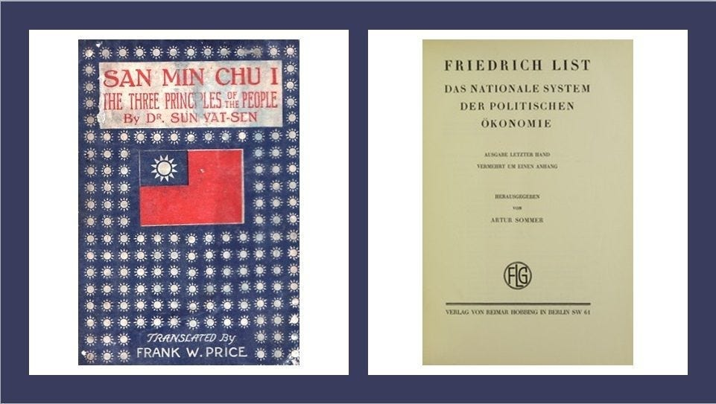](https://substackcdn.com/image/fetch/f_auto,q_auto:good,fl_progressive:steep/https:/bucketeer-e05bbc84-baa3-437e-9518-adb32be77984.s3.amazonaws.com/public/images/e4855e45-76c1-4f6e-8680-36b4ab58bc5b_961x543.jpeg)](https://substackcdn.com/image/fetch/f_auto,q_auto:good,fl_progressive:steep/https%3A%2F%2Fbucketeer-e05bbc84-baa3-437e-9518-adb32be77984.s3.amazonaws.com%2Fpublic%2Fimages%2Fe4855e45-76c1-4f6e-8680-36b4ab58bc5b_961x543.jpeg" \t "_blank)

The Three Principles of the People by Sun Yat-sen and The National System of Political Economy by Friedrich List were both modelled off of American System economics.

It was crystal clear that the leadership of the world had embarked upon a common path and was desirous to enter a new age where slavery might truly become a thing of the past; that the individual was from henceforth to be seen as sacrosanct, that after centuries of brutal war the world was finally ready for peace and was willing to uphold liberty and freedom for all.

Was it just a dream?

No, it was not just a dream, although it was just as fleeting. The reason for this is found in the list of names below.

[[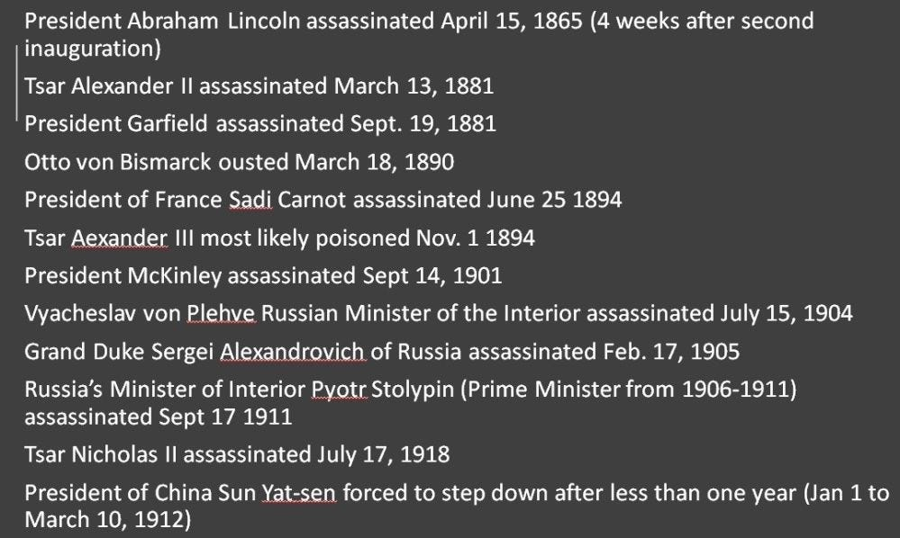](https://substackcdn.com/image/fetch/f_auto,q_auto:good,fl_progressive:steep/https:/bucketeer-e05bbc84-baa3-437e-9518-adb32be77984.s3.amazonaws.com/public/images/5e791efd-67da-44a6-8eb0-7069f3defe57_999x598.jpeg)](https://substackcdn.com/image/fetch/f_auto,q_auto:good,fl_progressive:steep/https%3A%2F%2Fbucketeer-e05bbc84-baa3-437e-9518-adb32be77984.s3.amazonaws.com%2Fpublic%2Fimages%2F5e791efd-67da-44a6-8eb0-7069f3defe57_999x598.jpeg" \t "_blank)

This list is by no means complete, there are many more names that were assassinated or ousted from their positions in this purge of “American System” supporters.

Yet, not even this ongoing purge was seen as enough to guarantee that nothing again would rise in opposition to the system of empire. It was for this reason that the world was dragged into two world wars…

Through A Glass Darkly is a reader-supported publication. To receive new posts and support my work, consider becoming a free or paid subscriber.

Top of Form

Subscribe

Bottom of Form

## Liberty for All?

“*Two systems are before the world; the one looks to increasing the proportion of persons and of capital engaged in trade and transportation, and therefore to diminishing the proportion engaged in producing commodities with which to trade, with necessarily diminished return to the labor of all; while the other looks to increasing the proportion engaged in the work of production, and diminishing that engaged in trade and transportation, with increased return to all, giving to the laborer good wages, and to the owner of capital good profits… One looks to pauperism, ignorance, depopulation, and barbarism; the other in increasing wealth, comfort, intelligence, combination of action, and civilization. One looks towards universal war; the other towards universal peace.****One is the English system; the other we may be proud to call the American system, for it is the only one ever devised the tendency of which was that of elevating while equalizing the condition of man throughout the world***.”

– Henry C. Carey, *Harmony of Interests*, 1851

These words written by Henry C. Carey at one time were understood by many to be the inherent difference between the English vs American economic system. However, today, we have forgotten much about what constitutes the American system.

Romans too, were once faced with a similar existential circumstance.

Junius Brutus, known as [the man who saved Rome](https://cynthiachung.substack.com/p/how-to-conquer-tyranny-and-avoid-a9e), ended the tyranny of King Superbus’ rule during Rome’s Age of Kingdoms. It was Junius Brutus’ actions that brought about the formation of the Roman Republic, and it was he who had the Roman people vow that never again would they accept the arbitrary rule of a king.

However, over the course of nearly five hundred years, the Roman people increasingly forgot this important lesson and what it meant to be a Roman citizen. In 49 BCE, Julius Caesar crossed the Rubicon leading to civil war and the Roman people offered him a crown for it.

The Roman people had forgotten what it meant to be a Roman citizen. They had forgotten that a free people who upheld dignity and liberty above all else would never accept to serve under the arbitrary rule of a king, an emperor. And upon forgetting such a thing, they had stripped themselves of any valour they once held. They had become mere subjects, at the mercy of whoever found themselves for that brief moment sitting on the throne (for more on this story [refer here](https://cynthiachung.substack.com/p/how-to-conquer-tyranny-and-avoid-a9e)).

If we are not careful, such a moment will also visit us…

\*\*\*

The world wars were fought to divide the partnerships that were forming against the system of empire. Germany and the United States were to be pitted against one another in both world wars. Japan was also to be pitted against the United States in the second world war. As a result, the economies of Germany and Japan were greatly set back, and their sovereignty was null and void. From post-WWII on, Germany and Japan had no choice but to enforce the will of the newly established Anglo-American Empire (for the story of how Britain created both world wars refer to Carroll Quigley’s book “The Anglo-American Establishment” [and my paper](https://cynthiachung.substack.com/p/operation-gladio-how-nato-conducted)).

Russia and China were all that was left. Hence, 76 years of Cold War going strong…

But how did the United States get drawn in by Britain as a consequence of the world wars?

## Under the Surrounding Sea of Dictatorship

“*Western Europe has only 20 to 30 more years of democracy left in it; after that it will slide, engineless and rudderless, under the surrounding sea of dictatorship, and whether the dictation comes from a politburo or a junta will not make that much difference.*”

– Willy Brandt (German Federal Chancellor, right before he stepped down in 1974)

What Willy Brandt, who Samuel P. Huntington so fondly quotes in both his “*The Crisis of Democracy*” and “*Disaffected Democracies*” leaves out was that this was not only [envisioned as an inevitability](https://cynthiachung.substack.com/p/the-enemy-within-a-story-of-the-purge-cda) for Western Europe, but for the United States as well.

Churchill had announced the Iron Curtain on March 5th, 1946, declaring the Soviet Union and China as the next targets in sight. If the United States were to commit to this long-term cold war stand-off, it was understood that it was only a matter of time before they increasingly saw the necessity of empire, of a global dictatorship and abandon their constitutional ideals.

In August 1946, after nuclear bombs were dropped on Hiroshima and Nagasaki, Bertrand Russell (member of the Fabian Society and British grand strategist) wrote *The Bomb and Civilization*, calling for a one world government:

“*Either war or civilization must end and if it is to be war that ends, there must be an international authority, with the sole power to make the new bombs…But I fear that all of this is utopian…If America were more imperialistic, there would be another possibility, less utopian and less desirable, but still preferable to obliteration of civilized life. It would be possible for Americans to use their position of superiority to insist upon disarmament not only in Germany and Japan, but everywhere except the United States, or at any rate, in every country not prepared to enter into a close military alliance with the United States…During the next few years, this policy should be enforced. If one or two wars were necessary, they would be brief and would soon end in decisive American victory.****In this way, a new League of Nations could be formed under American leadership,****and the peace of the world could be securely established. But I fear that respect for international justice would stop Washington from adopting this ‘policy’*.”

Just a few months later, in October 1946, Russell writes *On the End of Nation-States* published in the *Bulletin of Atomic Scientists*:

“*There is only one way in which great wars can be permanently prevented, and that is the establishment of an international government…There is one other method by which in theory the peace of the world could be secured, and that is the supremacy of one nation or one closely allied group of nations. By this method, Rome secured the peace of the Mediterranean area for several centuries. America at this moment, if it were bellicose and imperialistic could compel the rest of the world to disarm, and establish a worldwide monopoly of American armed forces. But the country has no wish for such enterprises. And in a few years, the opportunity will be gone. In the near future a world war, however terrible, would probably end in American victory without the destruction of civilization in the Western Hemisphere. An American victory would no doubt lead to a world government under the hegemony of the United States, a result which for my part I should welcome with enthusiasm*.”

Incredibly, in the year 1946, a little over a year after the end of WWII, Russell was calling for yet another world war, a war that would finish off the last two countries who threatened Anglo-American global hegemony, Russia and China.

The reason why Russell was stating that in a few years the opportunity would be gone was in reference to the Soviet Union and China getting the bomb, to which at that point, the great strategic advantage of the United States with seemingly next to nil consequence, this window of “opportunity” for unilateral colossal destruction would be lost.

It was for this reason that in November 1948, Russell while addressing a gathering at Westminster School, shocked his listeners when he advocated a pre-emptive nuclear strike against the Soviet Union. He argued that a war between the United States and the Soviet Union was inevitable. It would, therefore, be a humanitarian gesture to get a nuclear war over with quickly and unilaterally.

On the 29th of August 1949, the Soviet Union conducted its first successful weapon test. The so-called window of “opportunity” was lost for the formation of a quick American led global domination.

The Soviets had discovered how to create an atomic bomb several years before the 1953 date forecast by the CIA. This advent was a discouraging one for those who had had similar hopes to that of Russell, however, they understood it not as all hope was lost, but that a much longer game would now have to be played.

The Soviets acquisition of the atomic bomb was used as a justification to form a military industrial complex within the United States.

The Joint Intelligence Committee submitted an estimate of the nature of the nuclear threat from the Soviets. JIC-502, titled “Implications of Soviet Possession of Atomic Weapons” and drafted January 20th 1950 claimed that once the Soviets had 200 atomic bombs, they could launch a surprise attack and defeat the United States.

It was JIC-502 which would be the first to put forward a justification for the preventive first strike concept, supported by a massive military buildup under the pretence of pre-emptive war.

[NSC-68](https://web.archive.org/web/20220521054319/https:/digitalarchive.wilsoncenter.org/document/116191.pdf?v=2699956db534c1821edefa61b8c13ffe) would be drafted the same year, declaring that the U.S. was in the moral equivalent of war with the Soviet Union and called for a massive military buildup to be completed by 1954 dubbed the “year of maximum danger”, the year JIC-502 claimed the Soviets would achieve military superiority and be able to launch war against the U.S. This proposed military buildup would increase the defense budget from $10 billion to $40 billion from 1950-53. (As we now know this decision was not based on any actual observations of Soviet capability or intention, for more on this [refer here](https://cynthiachung.substack.com/p/in-search-of-monsters-to-destroy).)

During this same period another security doctrine was drafted, titled “NSC-75: A Report to the NSC by the Executive Secretary on British Military Commitments”. The report concluded that if the British Empire collapsed, and Britain could no longer carry out these deployments, in defending the “free world” against the Soviets, the U.S. would not be able to carry out its current foreign policy, including NSC-68.

**It was thus concluded in the report that it would be more cost-effective to aid Britain in saving its Empire!**

If you were ever wondering why the CIA was constantly found paired with British Intelligence, starting from its very inception, in a series of coups in countries they had no reason to be in, now you know why (for more on this [refer here](https://cynthiachung.substack.com/p/the-enemy-within-a-story-of-the-purge-cda)).

The U.S. had gone from an explicit mission to end imperialism worldwide under Roosevelt, to actively supporting and upholding British colonies and vassal states under Truman.

Caesar had been handed his crown and the American people had no idea.

## A Century of War

As a consequence of this very foolish decision, the United States found itself doing the bidding of the British Empire, and there was a great deal to do after WWII in re-securing British interests.

You see, much of the world had understood WWII to be about the sovereignty of nation-states against the tyranny of fascism and empire. After all, the imperialists and the fascists were often found linked hand in hand, as seen with Edward VIII (though he was not alone in the British Royal family in his views), the Vichy government in France, King of Italy Victor Emmanuel III who appointed Benito Mussolini as Prime Minister in 1922 (who only deposed Mussolini in 1943 when it was clear they were going to lose the war) and Imperial Japan under Emperor Hirohito.

It is for this reason that we saw, before WWII was even over, the imperialists and the fascists in discussion with each other as to what would form the post-war world. It is for this reason that the countries chosen to oversee this post-WWII Grand Strategy would be the U.S., Britain, France, Germany and Japan, rather than Roosevelt’s choice of the U.S., Russia, Britain and China.

However, countries from all throughout the world started to rise up against their colonial oppressors once WWII was “won.” For they understood that if freedom and sovereignty for all had indeed won, there was no further place for the brutal rule of colonialism. Finally, all countries would have the right for self-determination.

Ho Chi Minh, a Roosevelt ally who had fought against the Japanese fascist imperialists during WWII, signed the Declaration of Independence for a new nation, the Democratic Republic of Vietnam on September 2nd, 1945, stating the following:

“*A people who have courageously opposed French domination for more than eighty years, a people who have fought side by side with the Allies against the Fascists during these last years—such a people must be free and independent*.”

After a long and horrific battle against the ruthless Japanese fascists, with support during the war from the United States and China, it was the hope of Ho Chi Minh that Vietnam could return to its former days of peace with its new-found independence from colonial rule.

Instead, the French would re-enter into Vietnam to re-secure their colonial asset. When sparks of revolution also started to form in Algeria, the United States agreed to enter Vietnam in support of France’s colonial interests (for more on this [refer here](https://cynthiachung.substack.com/p/the-us-pivot-to-asia-cold-war-lessons)).

There was also another reason.

In the November 3rd, 1965 Draft Memorandum from Secretary of Defense McNamara to President Johnson, it is written under “[Courses of Action in Vietnam](https://web.archive.org/web/20220727023006/https:/history.state.gov/historicaldocuments/frus1964-68v03/d189)”:

“*The February decision to bomb North Vietnam and the July approval of Phase I deployments make sense only if they are in support of a long-run United States policy to contain Communist China. China – like Germany in 1917, like Germany in the West and Japan in the East in the late 30’s, and like the USSR in 1947 – looms as a major power threatening to undercut our importance and effectiveness in the world and, more remotely but more menacingly, to organize all of Asia against us…This understanding of a straightforward security threat is interwoven with another perception****– namely, that we have our view of the way the US should be moving and of the need for the majority of the rest of the world to be moving in the same direction if we are to achieve our national objective…the role we have inherited and have chosen for ourselves for the future is to extend our influence and power to thwart ideologies that are hostile to these aims and to move the world, as best we can, in the direction we prefer****.****Our ends cannot be achieved and our leadership role cannot be played if some powerful and virulent nation -whether Germany, Japan, Russia or China – is allowed to organize their part of the world according to a philosophy contrary to ours***.”

A philosophy that counters Anglo-American supremacy that is.

## Bandung Conference: The Voice of the People for The 5 Principles of Panscheel

Despite the Americans launching the Korean War from 1950 to 1953, and partaking in a [coup alongside British MI6 of Iran’s Prime Minister Mosaddegh](https://risingtidefoundation.net/2021/06/19/irans-century-and-a-half-fight-for-sovereignty/) and derailing Iran’s century and a half fight for sovereignty, much of the world still remained hopeful that the United States had not yet fully succumbed to the siren’s call towards empire.

It was for this reason that the Bandung Conference was held, a conference you have likely never heard of, and where **more than half of the world’s population was represented in their call for the right to self-determination**. It was these countries’ hope that the United States would be in support of this, for they understood that they were unlikely to succeed in their defiance against systems of empire without American support.

They also understood that **the United States’ founding principles were for this very thing and it was their hope that Americans would remember their original cause against empire.**

[[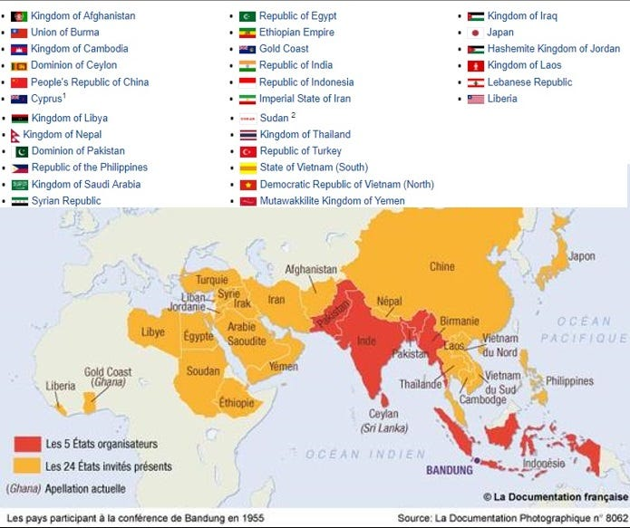](https://substackcdn.com/image/fetch/f_auto,q_auto:good,fl_progressive:steep/https:/bucketeer-e05bbc84-baa3-437e-9518-adb32be77984.s3.amazonaws.com/public/images/b903c83d-24fe-4c4f-a564-a84bcb2a5e03_695x583.jpeg)](https://substackcdn.com/image/fetch/f_auto,q_auto:good,fl_progressive:steep/https%3A%2F%2Fbucketeer-e05bbc84-baa3-437e-9518-adb32be77984.s3.amazonaws.com%2Fpublic%2Fimages%2Fb903c83d-24fe-4c4f-a564-a84bcb2a5e03_695x583.jpeg" \t "_blank)

The Bandung Conference held in April 1955 was the first large-scale Asian–African Conference in history, its five organisers were Indonesia, India, Sri Lanka (formerly the British colony Ceylon), Myanmar (formerly the British colony Burma), and Pakistan (all fresh out of British and Dutch colonialism). The conference took place over six days and was held in Bandung, West Java, Indonesia. 29 countries participated, representing a total population of 1.5 billion people, 54% of the world’s population at the time.

The conference’s stated aims were to promote Afro-Asian economic and cultural cooperation and to oppose colonialism or neocolonialism by any nation. The conference was an important step towards the eventual creation of the Non-Aligned Movement, which was as an effort to avoid the polarized world of the Cold War between Communist and Capitalist states. Drawing on the principles agreed at the Bandung Conference in 1955, the Non-Aligned Movement was established in 1961 in Belgrade, Yugoslavia through an initiative of the Indian Prime Minister Jawaharlal Nehru, Ghanaian President Kwame Nkrumah, Indonesian President Sukarno, Egyptian President Gamal Abdel Nasser and Yugoslav President Josip Broz Tito.

[[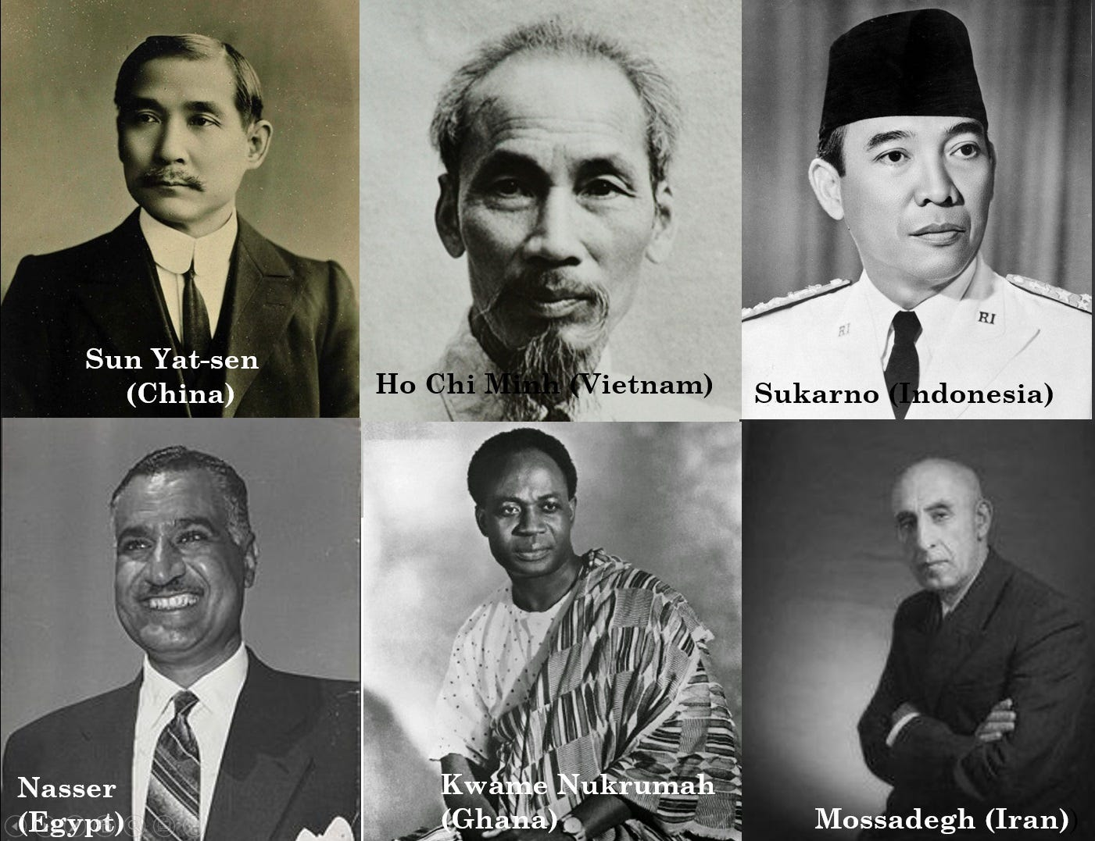](https://substackcdn.com/image/fetch/f_auto,q_auto:good,fl_progressive:steep/https:/bucketeer-e05bbc84-baa3-437e-9518-adb32be77984.s3.amazonaws.com/public/images/c2a0ae52-cdec-4aab-9c22-fab7f0c0f309_1401x1077.jpeg)](https://substackcdn.com/image/fetch/f_auto,q_auto:good,fl_progressive:steep/https%3A%2F%2Fbucketeer-e05bbc84-baa3-437e-9518-adb32be77984.s3.amazonaws.com%2Fpublic%2Fimages%2Fc2a0ae52-cdec-4aab-9c22-fab7f0c0f309_1401x1077.jpeg" \t "_blank)

All of these men in the above picture were elected leaders of their respective countries who were adherents to The American System, and still had great hope for the United States to return to its roots as an anti-imperialist force in the world (for more on this [refer here](https://www.youtube.com/watch?v=i0tFlawT9vo).)

This was very much what made up the spirit of the Bandung Conference as seen by this statement by Sun Yat-sen, China’s first President of the Republic of China, in his book *A True Solution for the Chinese Question* (1904):

“*To work out the salvation of China is exclusively the duty of our own but as the problem has recently found a worldwide interest, we, in order to make sure of our success…must appeal to the people of the United States in particular for your sympathy and support, either moral or material, because you are the pioneers of western civilization in Japan: Because we intend to model our government after yours; Above all, because you are the champion of liberty and democracy. We hope to find many Lafayette’s among you*.”

And in his 1919 treatise:

[[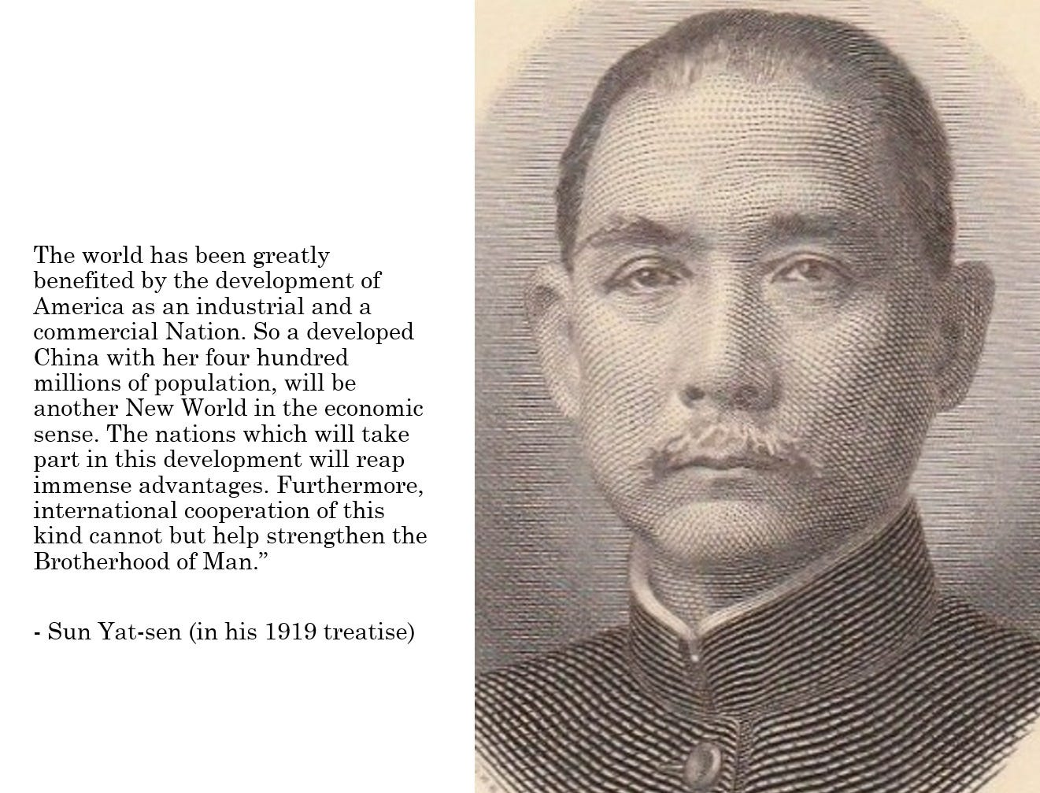](https://substackcdn.com/image/fetch/f_auto,q_auto:good,fl_progressive:steep/https:/bucketeer-e05bbc84-baa3-437e-9518-adb32be77984.s3.amazonaws.com/public/images/067ae1bf-d26a-4aae-a2d8-40e1969607f9_1321x1007.jpeg)](https://substackcdn.com/image/fetch/f_auto,q_auto:good,fl_progressive:steep/https%3A%2F%2Fbucketeer-e05bbc84-baa3-437e-9518-adb32be77984.s3.amazonaws.com%2Fpublic%2Fimages%2F067ae1bf-d26a-4aae-a2d8-40e1969607f9_1321x1007.jpeg" \t "_blank)

Within the opening speech at the Bandung Conference (April 1955), President Sukarno (one of its leading organisers) spoke:

*“Today is a famous anniversary in that battle –against colonialism. On the 18th of April, 1775, just 180 years ago, Paul Revere rode at midnight through the New England countryside, warning of the approach of the British troops and of the opening of the American War of Independence,****the first successful anti-colonialist war in histor****y. About this midnight ride the poet Longfellow wrote:*

*“A cry of defiance and not of fear,*

*“A voice in the darkness, a knock at the door,*

*“And a word that shall echo for evermore…”*

*Yes, it shall echo forevermore. That battle which began 180 years ago is not yet completely won.*

*…Colonialism has also its modern dress, in the form of economic control, intellectual control, actual physical control by a small but alien community within a nation…It behooves us to take particular care to ensure that the principle which is usually called the ‘live and let live principle’ – mark, I do not say the principle of laisser-faire, laisser-passer, of Liberalism, which is obsolete – is first of all applied by us most completely within our own Asian and African frontiers.”*

In April 1954 just before the Geneva Conference on Vietnam, Zhou Enlai, Premier of the People’s Republic of

* China, initiated bilateral agreements with
* India (under the leadership of Nehru) and with
* Myanmar (under the leadership of U Nu)

which established the Five Principles of Peaceful Co-Existence. This initiative by Zhou, Nehru and U Nu would become a central concept motivating the Spirit of Bandung.

[[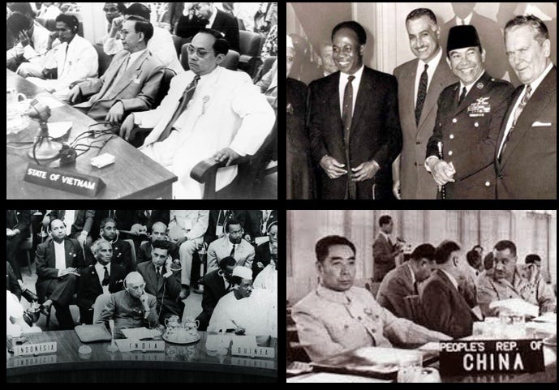](https://substackcdn.com/image/fetch/f_auto,q_auto:good,fl_progressive:steep/https:/bucketeer-e05bbc84-baa3-437e-9518-adb32be77984.s3.amazonaws.com/public/images/efc89961-f876-4dd3-9037-a574e28838b1_689x481.jpeg)](https://substackcdn.com/image/fetch/f_auto,q_auto:good,fl_progressive:steep/https%3A%2F%2Fbucketeer-e05bbc84-baa3-437e-9518-adb32be77984.s3.amazonaws.com%2Fpublic%2Fimages%2Fefc89961-f876-4dd3-9037-a574e28838b1_689x481.jpeg" \t "_blank)

Bandung Conference 1955.

[Panchsheel or Five Principles of Coexistence was a new set of principles](https://en.wikipedia.org/wiki/Five_Principles_of_Peaceful_Coexistence) for the conduct of international relations that would reflect the aspirations of all nations to co-exist and prosper together in peace and harmony. It was a peaceful offering as an alternative to the war mongering Cold War Doctrine.

[The Truman doctrine focuses on military aid, such as that lent to Greece and Turkey in the 1940’s whilst the Marshall Plan was a package of purely economic aid, at least outwardly (Borchard 1947: 885). –FNC]

[[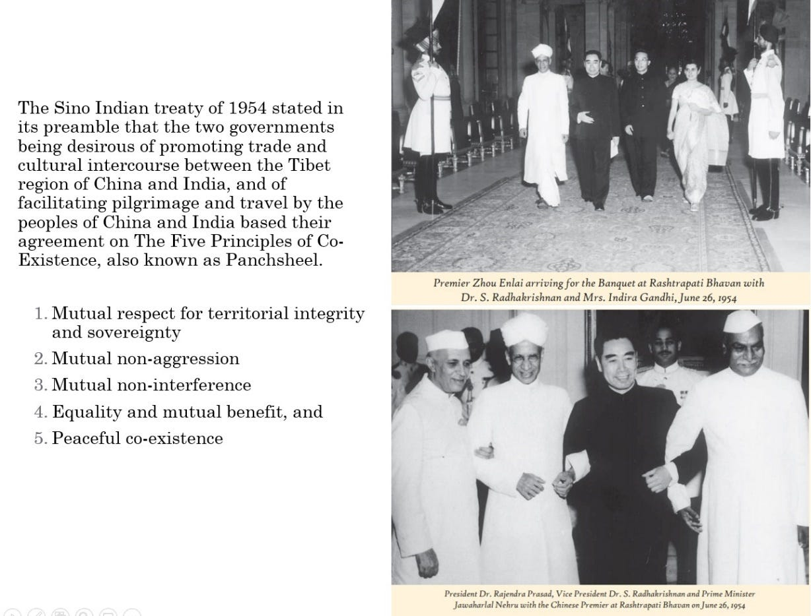](https://substackcdn.com/image/fetch/f_auto,q_auto:good,fl_progressive:steep/https:/bucketeer-e05bbc84-baa3-437e-9518-adb32be77984.s3.amazonaws.com/public/images/8aceac9c-055e-4fab-a232-71a2be4144c4_1228x934.jpeg)](https://substackcdn.com/image/fetch/f_auto,q_auto:good,fl_progressive:steep/https%3A%2F%2Fbucketeer-e05bbc84-baa3-437e-9518-adb32be77984.s3.amazonaws.com%2Fpublic%2Fimages%2F8aceac9c-055e-4fab-a232-71a2be4144c4_1228x934.jpeg" \t "_blank)

In 2005 the Ministry of External Affairs Government of India released a pamphlet for the 50th anniversary of Panchsheel:

“*The timeless relevance of Panchsheel is based on its firm roots in the cultural traditions of its originators, two of the world’s most ancient civilisations. The linkage that was established by the spread of Buddhism in China laid the historical basis for the formulation of the principles of Panchsheel by India and China.*

*On the 50th anniversary of Panchsheel, we can without hesitation say that its relevance, as embodied in the Joint Statement of 1954, shines as brightly today as when it was first conceived. Panchsheel was developed in the context of a post-colonial world where many were seeking an alternative ideology dedicated to peace and development of all.*

*Fifty years later, the world is now searching for an alternative to the adversarial constructs that dominated the Cold War era. Countries all over the world are focusing on creating extended and mutually supportive arrangements, and attempting to define a new economic, social and political world order in the context of globalisation, non-traditional security threats and the quest for multi-polarisation.*

*Today, Panchsheel can help the world move away from the traditional concepts of balance of power and competitive security, the consequent searching for an enemy, and the predicating of activities on conflicts rather than cooperation.*

*…What should be stressed today is that the principles of Panchsheel are not just empowering principles, they are also guiding principles that enshrine a certain code of behaviour. Their essence is the non-use of power, the approach of tolerance, ‘of living one’s life, learning from others but neither interfering nor being interfered with’, and the obligation to do unto others as you would have them do unto you. It may not be out of place in a world searching for moral certainties to emphasise this message of Panchsheel.”*

Through A Glass Darkly is a reader-supported publication. To receive new posts and support my work, consider becoming a free or paid subscriber.